Name: Christian Antonius Anggaresta

NIM: 2602179214

Total score: 115

Link github: <https://github.com/chrisprojs/connect-friend>

[LO1,LO2,LO3 & LO4, 20 points] User Authentication

Login

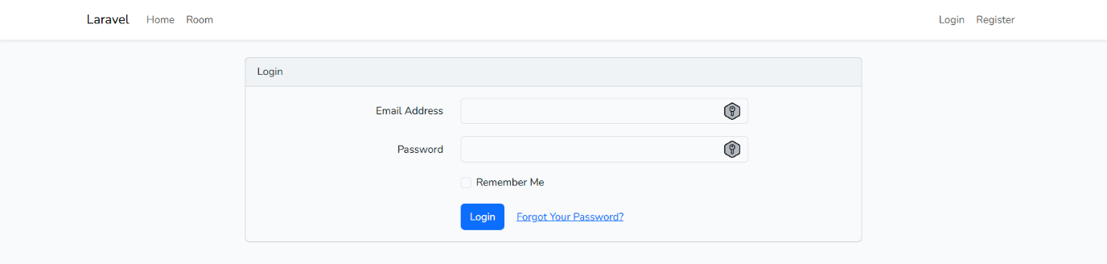

Register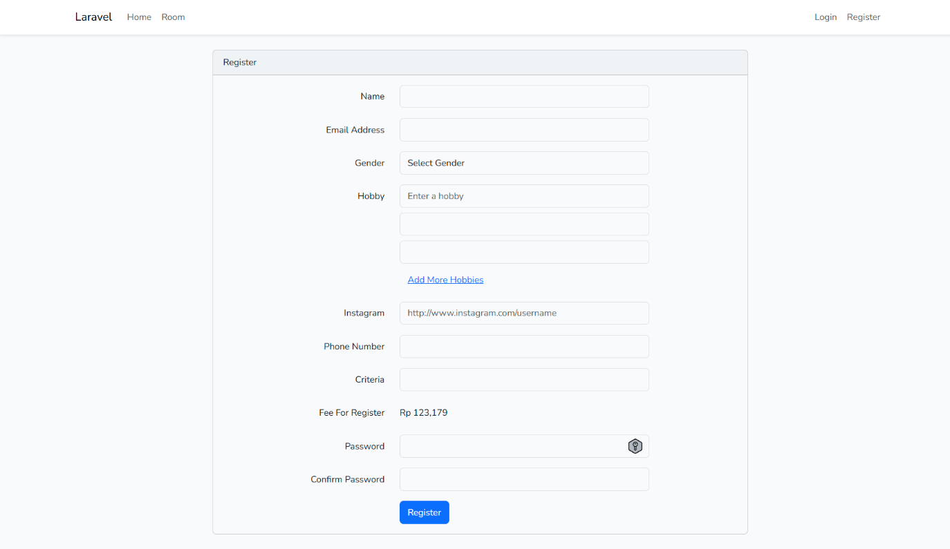

[LO1,LO2,LO3 & LO4, 10 points] Payment

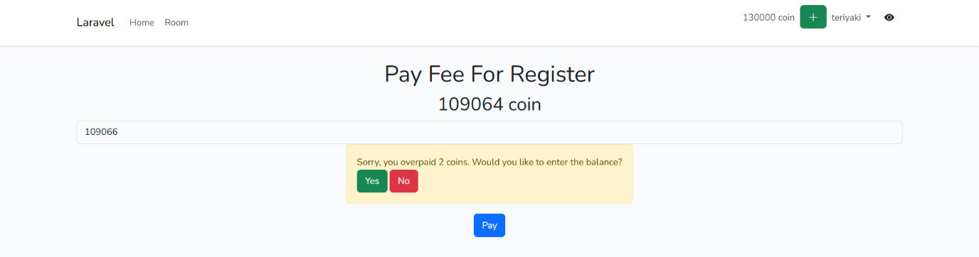

[LO1,LO2,LO3 & LO4, 30 points] Friends

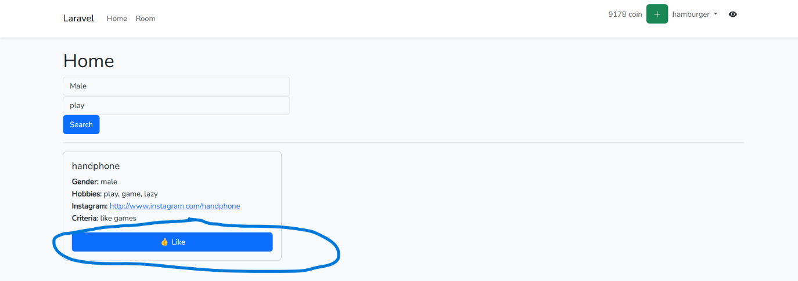

[LO1,LO2,LO3 & LO4, 10 points] Searching & Filtering

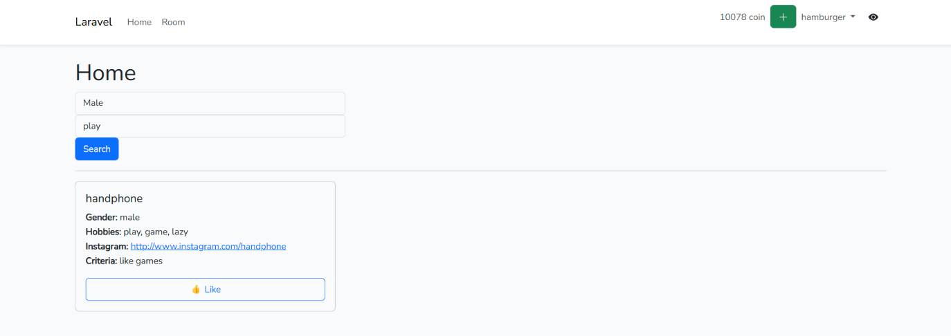

[LO1,LO2,LO3 & LO4, 15 points] Topup Coins

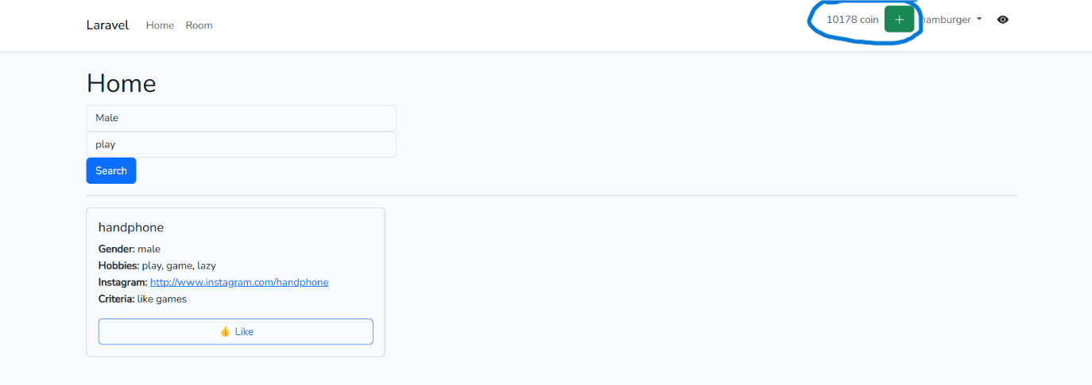

[LO1,LO2,LO3 & LO4, 30 points] Visible Profile

Invisible

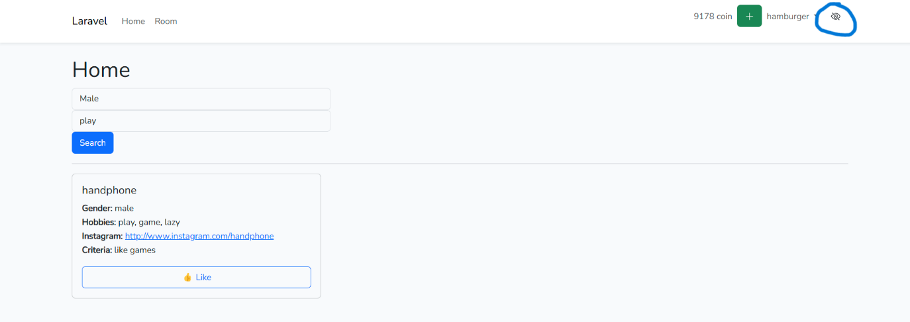

Can’t be searched by other user

